Smart Agricultural Production Optimization Engine (OptiCrop)

Project Description
Smart Agricultural Production Optimization Engine (OptiCrop) is a Machine Learning-based web application developed to help farmers select the most suitable crop based on soil and environmental conditions. The system analyzes important parameters such as Nitrogen (N), Phosphorous (P), Potassium (K), temperature, humidity, soil pH, and rainfall to recommend the best crop for cultivation.
The project follows a Machine Learning workflow that includes data preprocessing, model training, evaluation, and deployment. The trained model is integrated with a Flask-based web application, allowing users to enter soil and climate details and receive instant crop recommendations through a simple and user-friendly interface.
The application also helps users assess crop suitability under different environmental conditions, making it useful for farmers, researchers, and agricultural stakeholders. Developed using Python, Flask, Scikit-learn, Pandas, NumPy, Matplotlib, Seaborn, and SciPy, the project aims to improve agricultural productivity, support better decision-making, and encourage sustainable farming practices.

Abstract
Agriculture is one of the most important sectors that contributes to economic growth and food production. Selecting the right crop based on soil nutrients and environmental conditions is essential for improving agricultural productivity. The Smart Agricultural Production Optimization Engine (OptiCrop) is a Machine Learning-based web application developed to recommend the most suitable crop by analyzing parameters such as Nitrogen (N), Phosphorous (P), Potassium (K), temperature, humidity, pH, and rainfall.
The project uses a trained Machine Learning model to process the input data and provide accurate crop recommendations through a user-friendly Flask web application. The system enables farmers to make informed decisions, optimize the use of resources, and improve crop yield while reducing the risk of selecting unsuitable crops.
Developed using Python, Flask, Scikit-learn, Pandas, NumPy, Matplotlib, Seaborn, and SciPy, the application provides fast and reliable predictions based on scientific analysis of soil and climatic conditions. In addition to helping farmers, the system can also be used by agricultural researchers and policymakers to study crop suitability and support data-driven agricultural planning.
Overall, the OptiCrop project demonstrates how Machine Learning and web technologies can be applied to modern agriculture to improve productivity, encourage sustainable farming practices, and support efficient resource management.

Problem Statement
Agriculture plays a vital role in ensuring food security and economic growth. However, many farmers still rely on traditional farming practices and personal experience to select crops, which may not always match the current soil and climatic conditions. This can lead to reduced crop yields, inefficient use of resources, and financial losses.There is a need for an intelligent system that can analyze soil nutrients such as Nitrogen (N), Phosphorous (P), Potassium (K) along with environmental factors including temperature, humidity, pH, and rainfall to recommend the most suitable crop. A data-driven crop recommendation system can help farmers make informed decisions, improve productivity, optimize resource utilization, and promote sustainable agricultural practices.

Project Objectives
- To develop a Machine Learning-based system that recommends the most suitable crop based on soil and environmental conditions.
- To analyze key agricultural parameters such as Nitrogen (N), Phosphorous (P), Potassium (K), temperature, humidity, pH, and rainfall for accurate crop prediction.
- To provide farmers with quick and reliable crop recommendations through a user-friendly Flask web application.
- To improve agricultural productivity and optimize the efficient use of natural resources.
- To promote data-driven and sustainable farming practices by supporting informed decision-making.

Existing System
In the existing agricultural system, farmers mainly depend on traditional farming methods, personal experience, and expert advice to select suitable crops. Crop selection is often based on past practices rather than scientific analysis of soil nutrients and environmental conditions. This approach may result in inappropriate crop selection, lower productivity, and inefficient use of resources such as water and fertilizers.

Limitations of the Existing System
- Relies on manual decision-making and traditional knowledge.
- Does not accurately analyze soil and environmental parameters.
- May lead to low crop yield due to unsuitable crop selection.
- Time-consuming and less efficient in providing recommendations.
- Limited use of data-driven techniques for improving agricultural productivity.

Proposed System
The proposed system, Smart Agricultural Production Optimization Engine (OptiCrop), is a Machine Learning-based web application that recommends the most suitable crop by analyzing soil nutrients and environmental conditions. The system takes inputs such as Nitrogen (N), Phosphorous (P), Potassium (K), temperature, humidity, pH, and rainfall, processes them using a trained Machine Learning model, and provides accurate crop recommendations.
The application is developed using the Flask framework with a simple and user-friendly interface, enabling farmers to receive instant recommendations and assess crop suitability. This data-driven approach helps improve crop productivity, optimize resource utilization, and support sustainable agricultural practices.

Advantages of the Proposed System
- Provides accurate crop recommendations using Machine Learning.
- Analyzes both soil nutrients and environmental factors.
- Offers quick and user-friendly prediction through a web application.
- Helps improve crop yield and resource efficiency.
- Supports sustainable and data-driven farming decisions.
- The system provides accurate crop recommendations by analyzing soil nutrients and environmental conditions using Machine Learning. This helps farmers choose the most suitable crop for cultivation.
- It improves agricultural productivity by recommending crops that are best suited to the given soil and climate conditions. This results in better yield and higher farming efficiency.
- The application saves time by providing instant crop recommendations through a simple web interface. Farmers can make quick and informed decisions without manual analysis.
- The project promotes efficient utilization of resources such as water, fertilizers, and soil nutrients. This reduces unnecessary resource wastage and lowers farming costs.
- The system supports sustainable agriculture by encouraging data-driven farming practices. It can also be enhanced in the future by integrating real-time weather data and smart IoT devices.

Scope of the Project
The Smart Agricultural Production Optimization Engine (OptiCrop) is designed to support farmers by providing intelligent crop recommendations based on soil nutrients and environmental conditions. The system helps users make informed decisions that improve crop productivity and reduce the risk of selecting unsuitable crops.
The project can be used by farmers, agricultural researchers, and policymakers to analyze crop suitability under different environmental conditions. It also serves as a foundation for future enhancements, such as integrating real-time weather data, IoT-based soil sensors, fertilizer recommendations, and mobile application support. By promoting data-driven decision-making, the project contributes to efficient resource utilization and sustainable agricultural development.

Technical Architecture
The Smart Agricultural Production Optimization Engine (OptiCrop) follows a three-tier architecture consisting of the Presentation Layer, Application Layer, and Machine Learning Layer.
The Presentation Layer provides a user-friendly web interface where users enter soil and environmental parameters such as Nitrogen (N), Phosphorous (P), Potassium (K), temperature, humidity, pH, and rainfall.
The Application Layer, developed using the Flask framework, receives the user inputs, validates the data, processes the request, and communicates with the trained Machine Learning model.
The Machine Learning Layer contains the trained crop recommendation model (crop_model.pkl), which analyzes the input parameters and predicts the most suitable crop. The prediction result is then returned to the Flask application and displayed to the user through the web interface.
Architecture flow
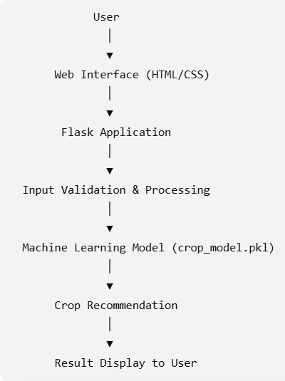

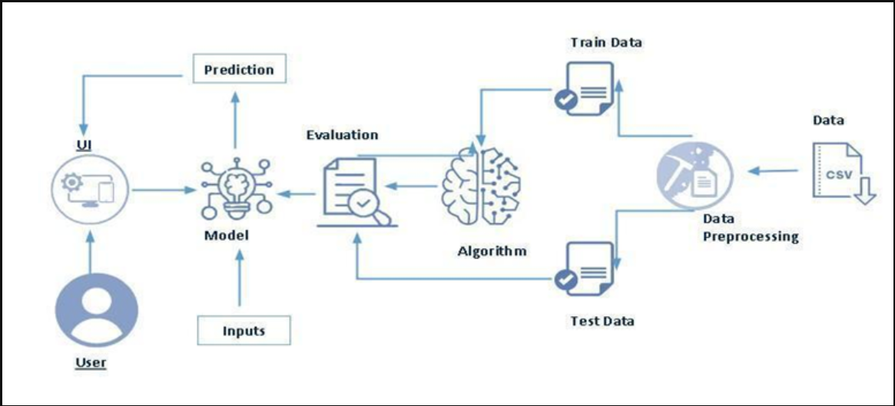

Project Workflow
The Smart Agricultural Production Optimization Engine (OptiCrop) performs the following steps:
- The user opens the OptiCrop web application.
- The user enters the required soil and environmental parameters, including Nitrogen (N), Phosphorous (P), Potassium (K), temperature, humidity, pH, and rainfall.
- The Flask backend receives and validates the entered data.
- The validated input is preprocessed and passed to the trained Machine Learning model.
- The Machine Learning model analyzes the input parameters and predicts the most suitable crop.
- The predicted crop recommendation is sent back to the Flask application.
- The application displays the recommended crop to the user through the result page.
- The user can use the recommendation to make informed agricultural decisions and improve crop productivity.
This workflow ensures fast, accurate, and real-time crop recommendations based on soil nutrients and environmental conditions.
Technologies Used
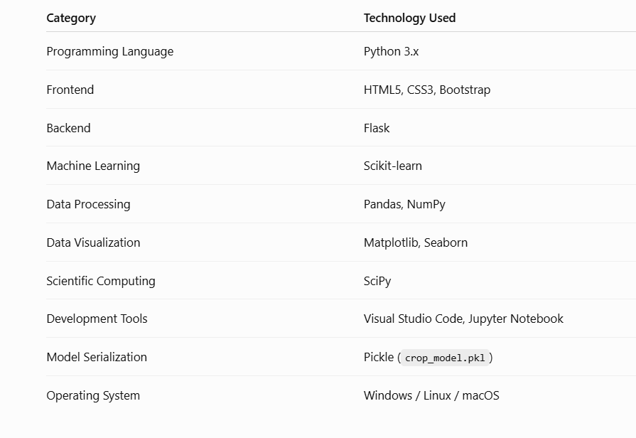

Software Requirements
- Operating System: Windows / Linux / macOS
- Python 3.x
- Flask Framework
- Visual Studio Code or PyCharm
- Jupyter Notebook / Anaconda Navigator
- NumPy
- Pandas
- Scikit-learn
- Matplotlib
- Seaborn
- SciPy
- Web Browser (Google Chrome, Microsoft Edge, etc.)

Hardware Requirements
- Processor: Intel Core i3 or above
- RAM: Minimum 4 GB
- Storage: Minimum 10 GB free space
- Internet Connection: Required for downloading libraries, datasets, and project setup

Implementation

Description
The implementation of the Smart Agricultural Production Optimization Engine (OptiCrop) combines Machine Learning with web application development to provide an intelligent crop recommendation system. The project is developed using Python and the Flask framework, while the Machine Learning model is built using the Scikit-learn library.
Initially, the crop recommendation dataset is collected and preprocessed by handling missing values, selecting relevant features, and preparing the data for model training. The processed dataset is then used to train the Machine Learning model, which learns the relationship between soil nutrients, environmental conditions, and suitable crops. After successful training, the model is saved as crop_model.pkl and integrated with the Flask application.
The web application provides a simple interface where users enter values such as Nitrogen (N), Phosphorous (P), Potassium (K), temperature, humidity, pH, and rainfall. The Flask backend receives the input, validates the data, and sends it to the trained Machine Learning model for prediction. The model analyzes the input parameters and identifies the most suitable crop for cultivation.
Finally, the predicted crop is displayed instantly on the result page, allowing users to make informed farming decisions. This implementation provides a fast, accurate, and user-friendly solution for crop recommendation, helping improve agricultural productivity and support sustainable farming practices.

Project Structure
The Smart Agricultural Production Optimization Engine (OptiCrop) project is organized into different files and folders to improve readability, maintainability, and efficient project management.
OptiCrop/
│
├── app.py
├── crop_model.pkl
├── Crop_recommendation.csv
├── requirements.txt
├── README.md
│
├── templates/
│ ├── index.html
│ ├── about.html
│ ├── recommendation.html
│ ├── suitability.html
│ ├── research.html
│ ├── result.html
│ └── contact.html
│
├── static/
│ ├── css/
│ ├── js/
│ └── images/
│
└── model/
└── Machine Learning Training Files
File Description
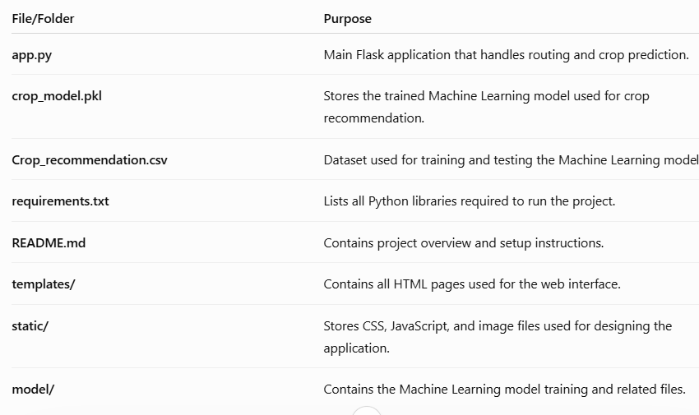

Test Cases
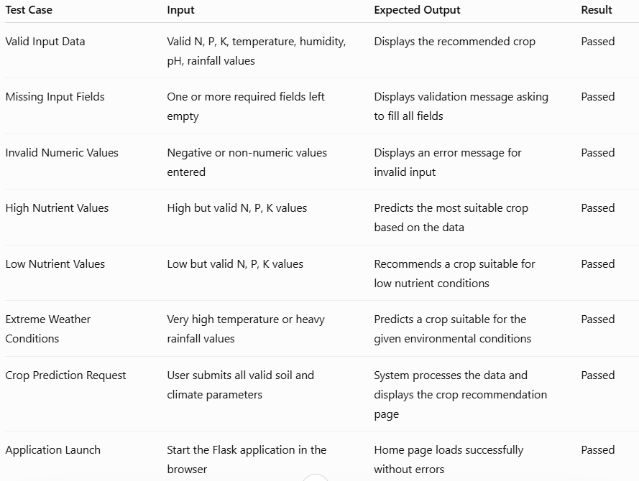

Outputs
Home Page
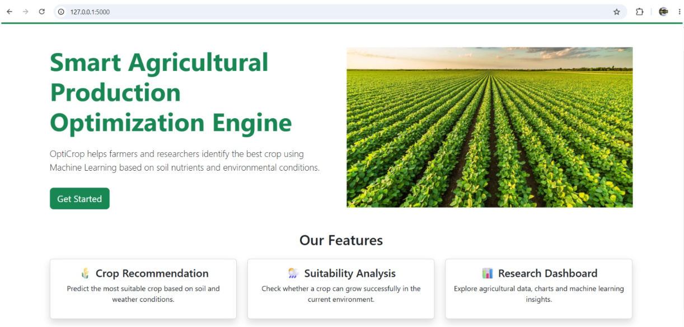
Recommendation
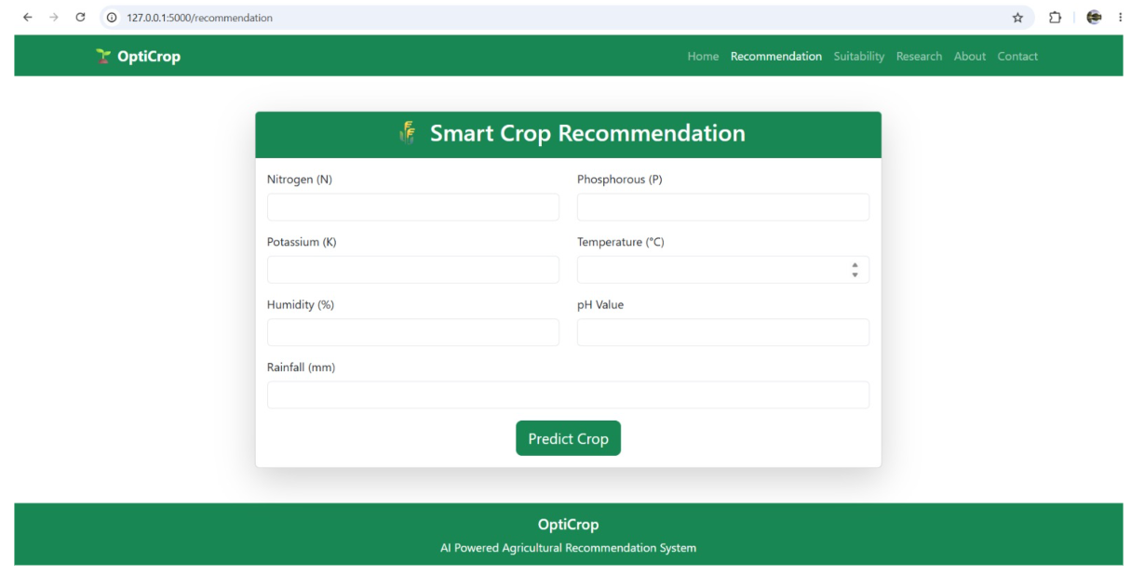

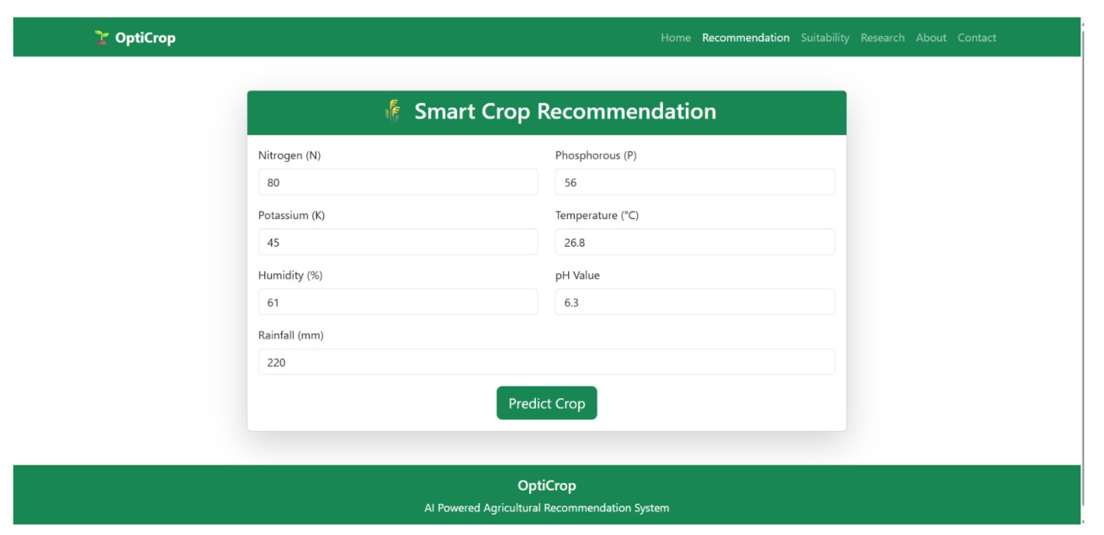Suitability
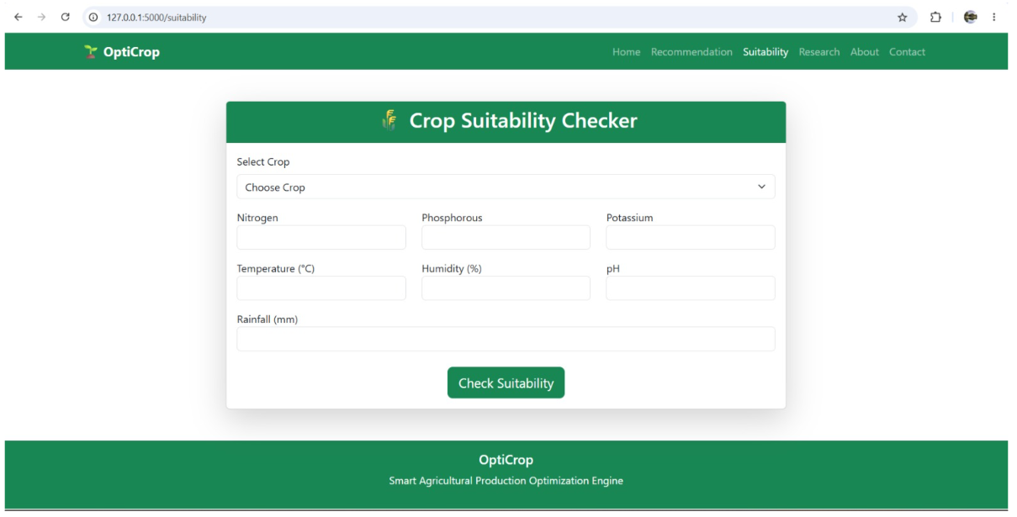

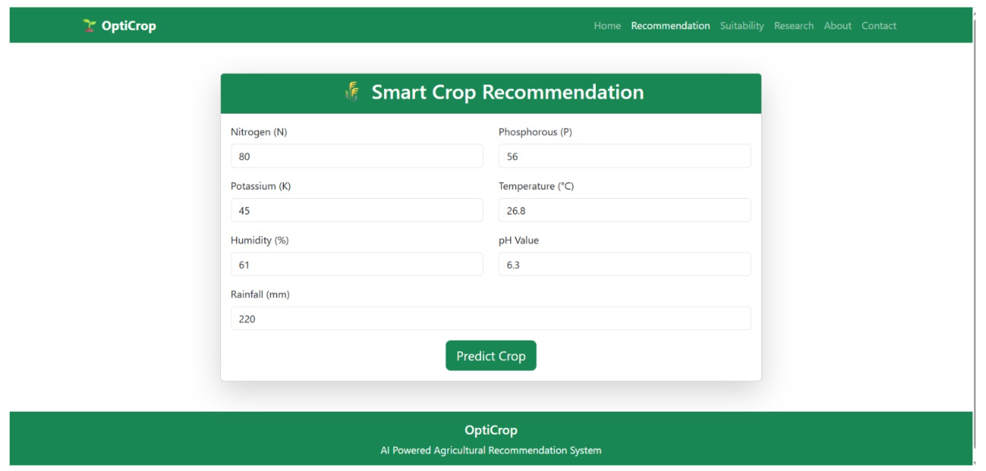Dashboard
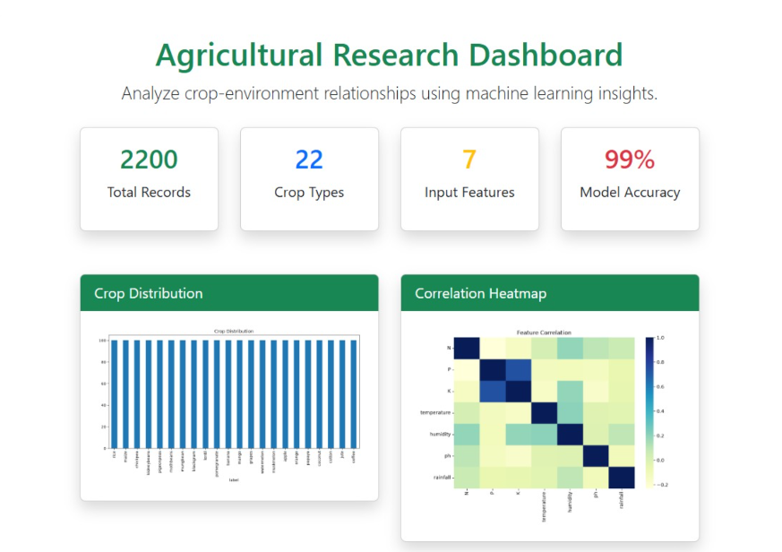

Analysis
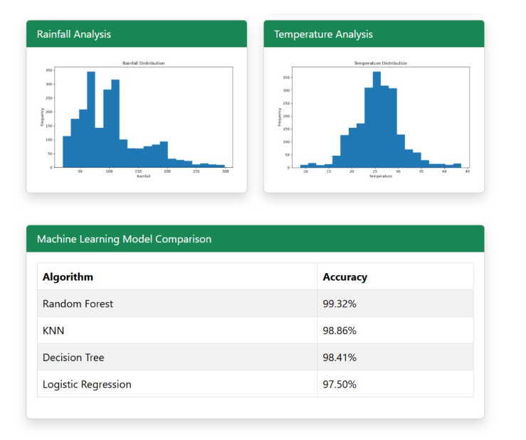

Contact Us


Conclusion
The Smart Agricultural Production Optimization Engine (OptiCrop) successfully demonstrates the application of Machine Learning in modern agriculture by providing intelligent crop recommendations based on soil and environmental conditions. The system analyzes important parameters such as Nitrogen (N), Phosphorous (P), Potassium (K), temperature, humidity, pH, and rainfall to recommend the most suitable crop for cultivation.
The project integrates a trained Machine Learning model with a Flask-based web application, enabling users to receive accurate crop recommendations through a simple and user-friendly interface. This approach helps farmers make informed decisions, improve crop productivity, and optimize the use of natural resources.
The application reduces dependence on traditional farming methods by providing data-driven recommendations, which can lead to better agricultural outcomes and increased farming efficiency. It also supports agricultural researchers and policymakers by offering insights into crop suitability under different environmental conditions.
Overall, the project successfully achieves its objectives of improving crop selection, enhancing agricultural productivity, and promoting sustainable farming practices. With future enhancements such as real-time weather integration, IoT-based soil monitoring, fertilizer recommendation systems, and mobile application support, the system has the potential to become a comprehensive smart agriculture solution for farmers and agricultural organizations.

